**INTO VPC**

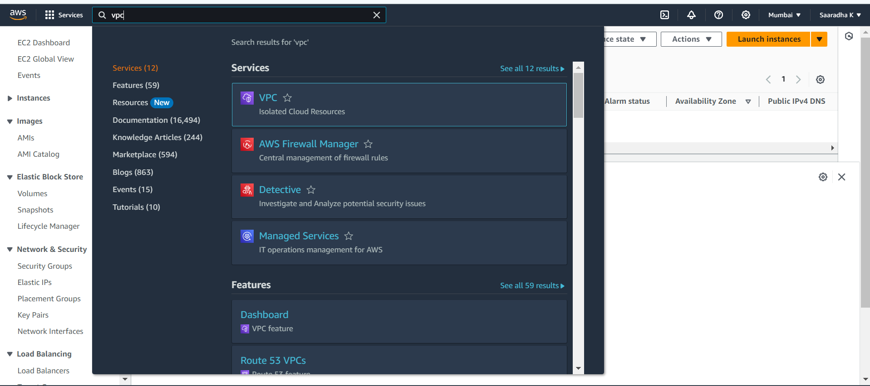

**DEFAULT VPC**

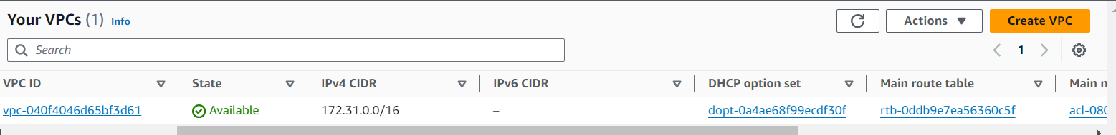

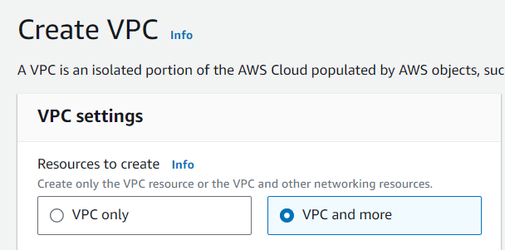

**NAME AND CIDR NOTATION FOR VPC**

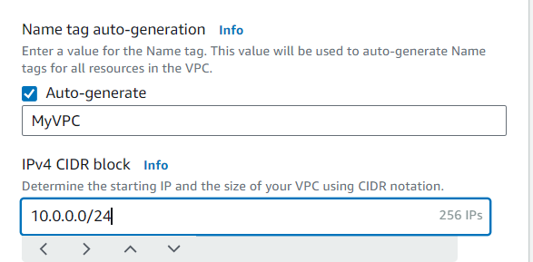

**PREFERED AVAILABILITY ZONES**

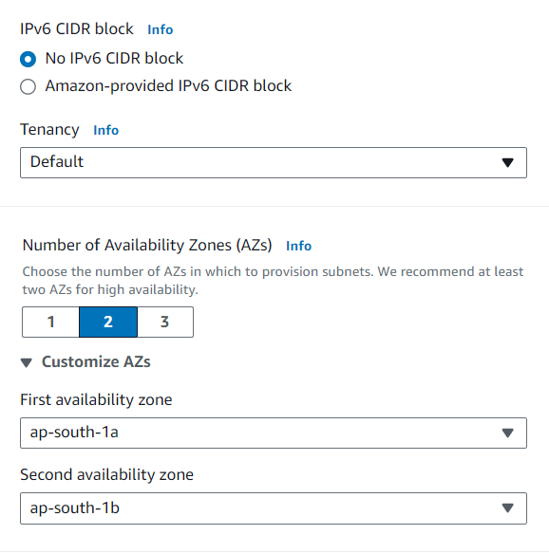

**CIDR BLOCKS FOR SUBNET**

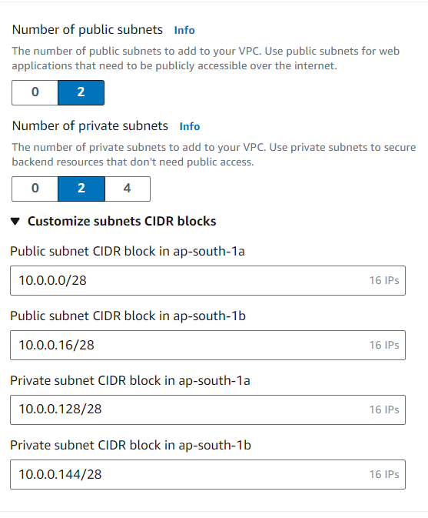

**NAT GATEWAY**

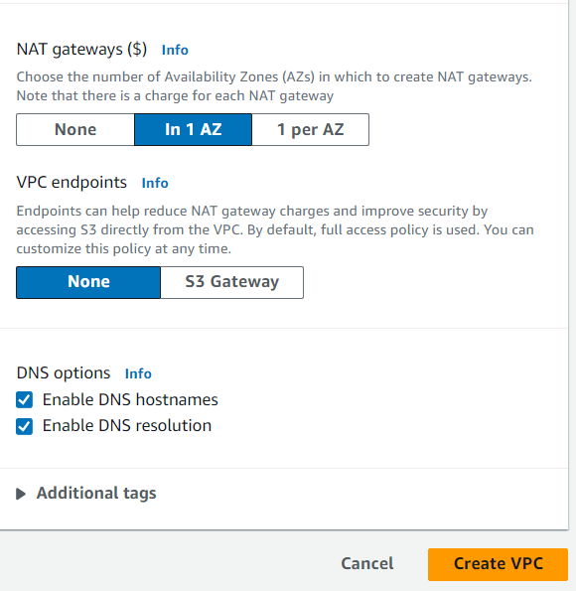

**CREATED VPC UNDER THESE PREFERENCES**

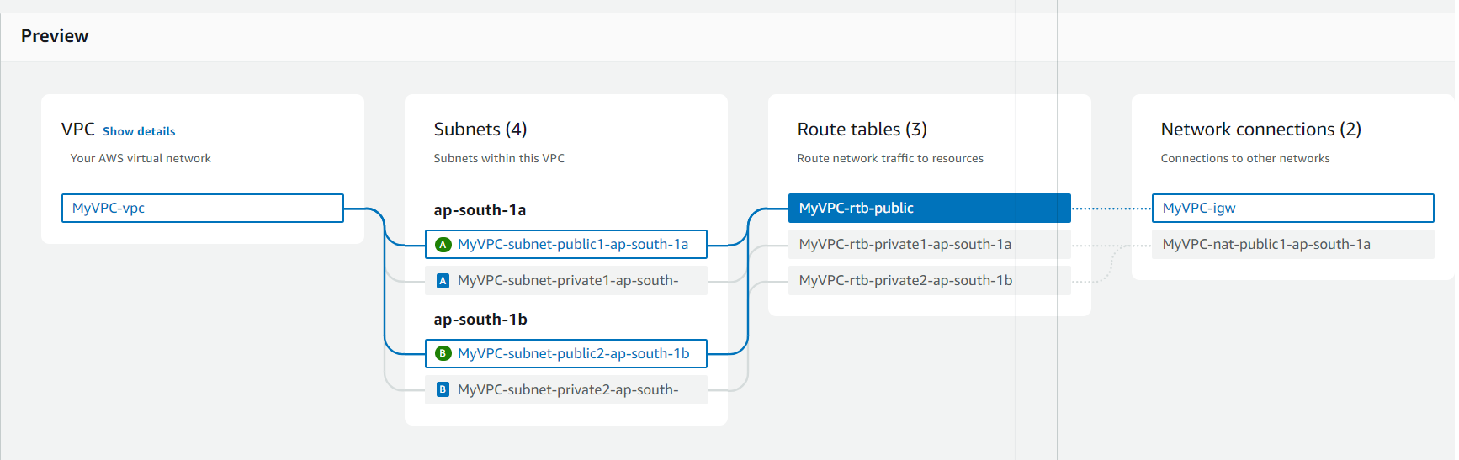

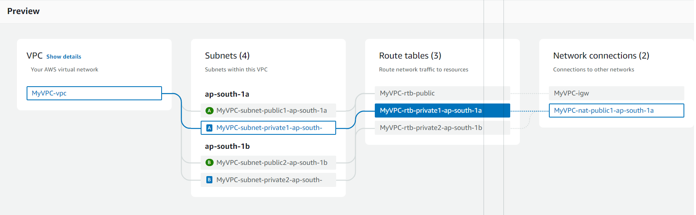

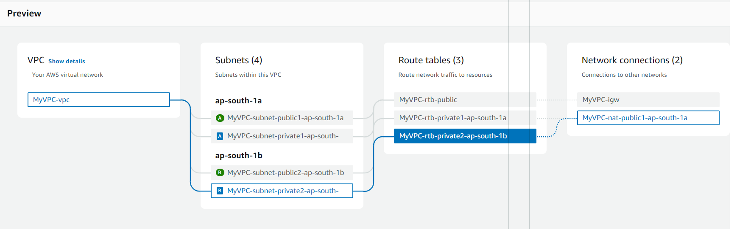

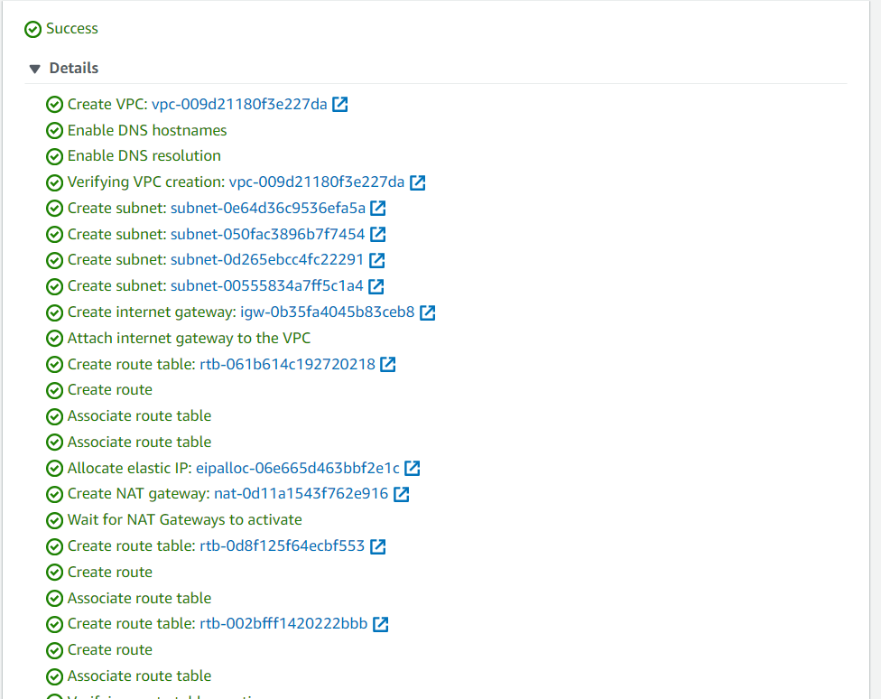

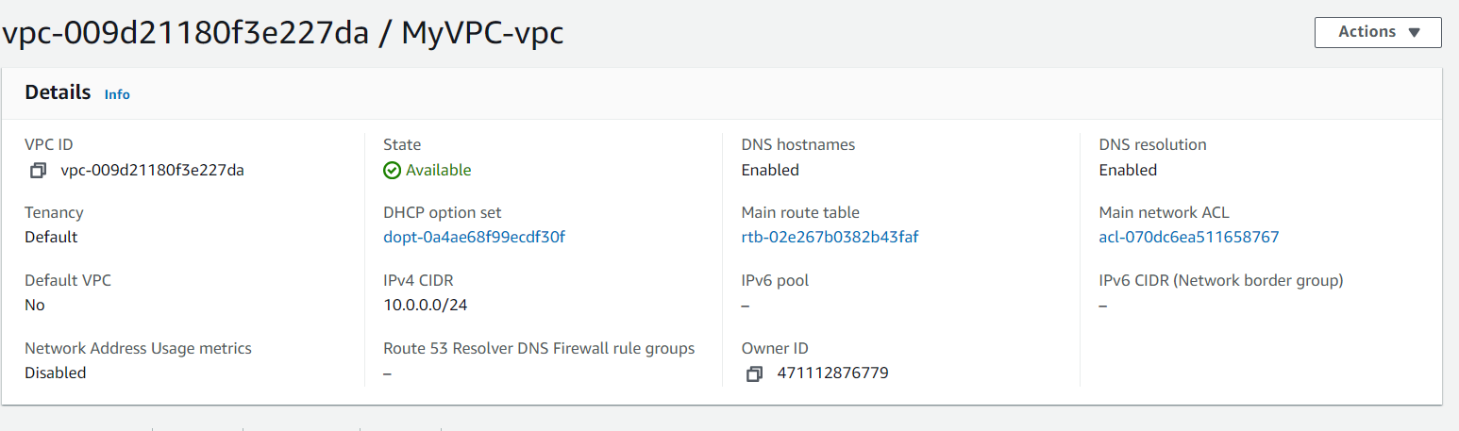

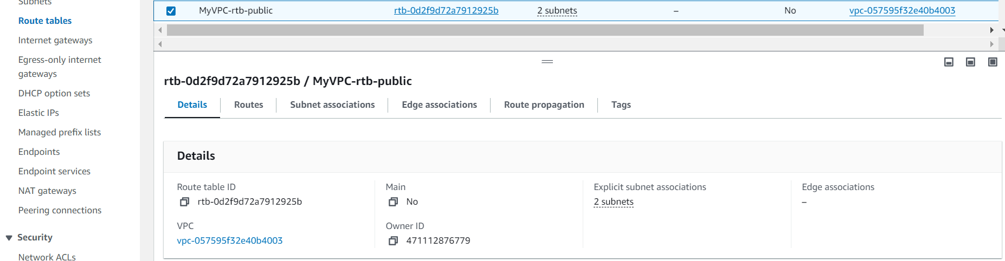

**DEFAULT SUBNET ASSOCIATIONS**

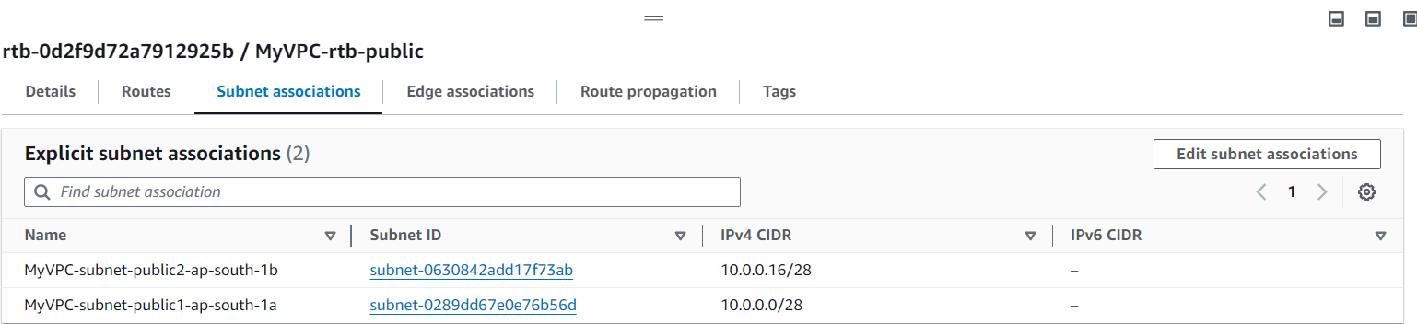

**LAUNCHING EC2 INSTANCE WITHIN YOUR VPC NETWORK**

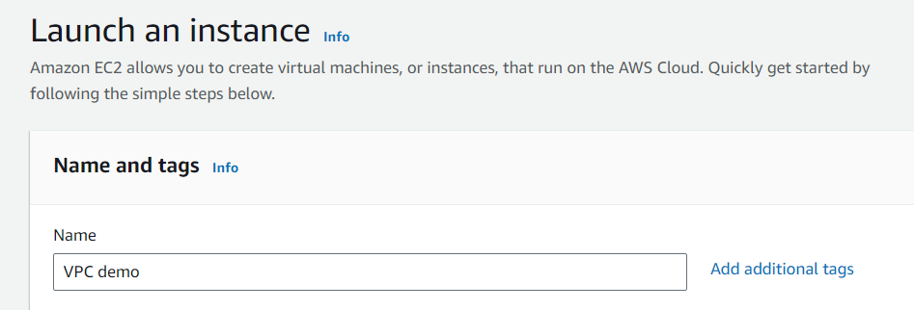

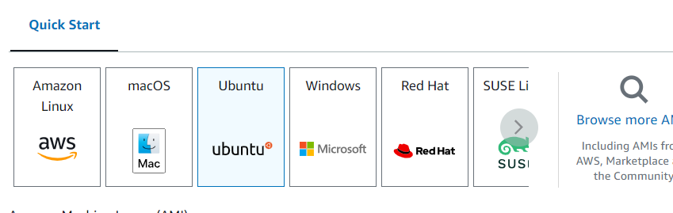

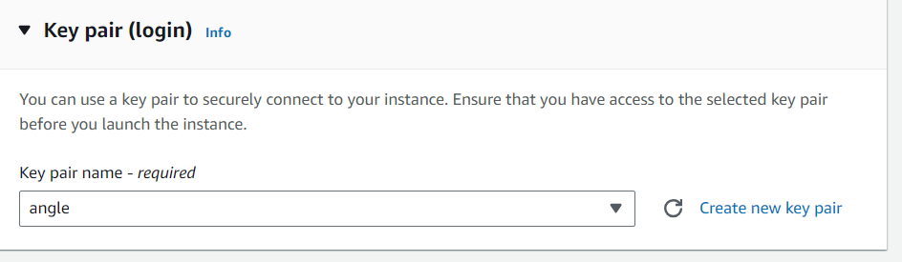

**USING ABOVE VPC AND PARTICULAR PUBLIC SUBNET**

